AI Literature Tutor (Lit Mind)

Submitted by:

Donthireddy Harini 12501562

Vamsi Krishna 12417819

Dharma Ayila 12417341

Course code: INT428
(Artificial Intelligence & Essentials)
Under the guidance of
Mr. Anuj Attri
School of Computer Science & Engineering


TABLE OF CONTENTS

1.Problem Statement …………………………………….1
2. Introduction …………………………………………...2
3. Objectives……………………………...........................3
4. Methodologies…………………………………………4
5. Features………………………………………………..5
6. Flowchart………………………………………………6
7. Technologies…………………………………………...7
8. Result…………………………………………………..8
9. Conclusion……………………………………………..9
10. Future Scope…………………………………………10
11. Chatbot-Based Project Evaluation…………………11
12. Implementation Evidence and Screenshots……….12
13. GitHub Repository Link …………………………...13

1)Problem Statement:
AI Literature Tutor:
The Situation: Students often struggle to understand complex literature, analyse themes, or write essays, leading to low engagement and frustration.
The Problem: Traditional studying is time-consuming, and general AI chatbots often just give answers, which prevents students from developing critical thinking skills or truly understanding the material.
The Goal: Develop an AI literature tutor that acts as an interactive coach—asking guiding questions, providing context, and encouraging analysis—to help students learn how to think about literature, rather than just telling them what to write.

2)Introduction to LitMind :
AI Literature Tutor is a sophisticated, AI-powered web application designed to serve as a high-level academic companion for literature students and enthusiasts. It goes beyond simple chat by offering deep literary analysis, textual criticism, and historical context through the lens of a "beloved professor."
It helps users analyse, understand, and engage with literary works through generative AI. It functions as a 24/7 personal assistant, moving beyond simple homework help to foster deeper critical thinking, analysis, and appreciation of text.

3)Objectives:
Interactive Literary Analysis:
Provide users with deep insights into character motivations, world literature, poetry forms, and literary theory.
Persistent Context:
Maintain conversation memory, user sessions, and past chat histories So users can continuously build upon previous discussions.
Seamless User Experience:
Offer easy accessibility via secure Google Authenticate login, alongside helpful quick-topic sidebar shortcuts.
Multimodal Capabilities:
Support image uploads so the AI can analyze visual symbolism or
artistic text representations from a literary perspective.
Enhance Essay Writing Skills:
To actively guide students in structuring academic essays,
constructing strong theses, acting as a writing coach rather than just writing the essays for them.
Encourage Reading Engagement:
To inspire users to read more deeply and discover new books.
By making connections across different texts, authors, and historical periods, the app aims to foster a genuine love for reading and literary exploration.
Voice-Activated Tutoring: By integrating browser-based speech recognition, the project aims to facilitate hands-free, conversational learning for users who process information better through dialogue.

4)Methodology:
- User Interaction: User sends text, voice, or image via the frontend.
- Auth Check: The server verifies the user's session (via Passport.js).
- Preprocessing: The backend retrieves recent message history from SQLite and formats the payload.
- Inference: Groq processes the request using Llama 3 models.
- Persistence: Both user input and AI output are saved to the local database for session retrieval.
- Rendering: The frontend receives Markdown text and renders it into formatted HTML using the editorial design system.

5)Features:
- Expert Literary Persona: A highly-tuned system prompt that ensures the AI acts as a "Literature Tutor," specializing in close reading, literary theory, and author biography.
- Llama-3 Integration (via Groq): Leverages the Llama-3.3-70b model for lightning-fast, high-quality academic responses.
- Markdown Formatting: All AI responses are rendered with full Mark down Support, including headers, italics for book titles, bold for literary terms, and blockquotes for textual excerpts.
- Socratic Dialogue: The AI is programmed to ask insightful follow-up questions to deepen the user's understanding of a text.
- Voice-to-Text Input: Integrated 🎤 voice recognition allows users to "speak" their questions, making the experience more conversational and accessible.
- Persistent Chat History: A dedicated sidebar to manage, rename, and delete past conversations, allowing you to pick up right where you left off.

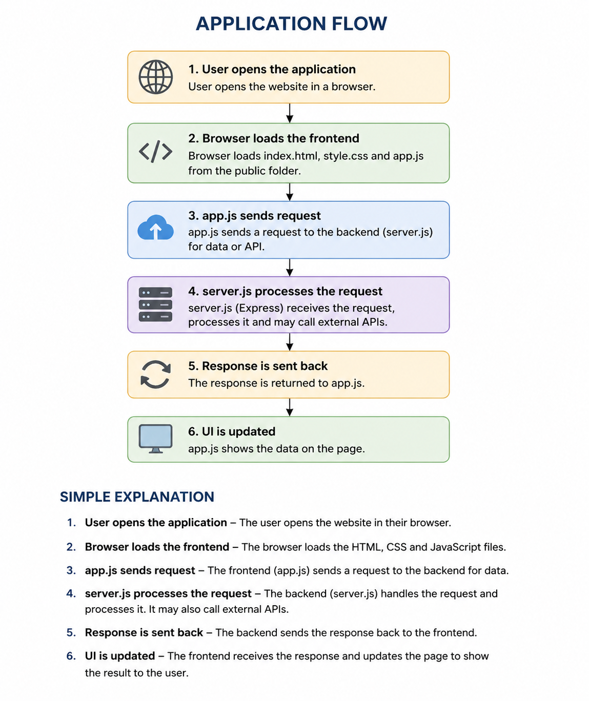
6)Flowchart

Litmind
├── public
│ ├── index.html ← Main HTML page
│ ├── style.css ← All styles
│ └── app.js ← Frontend JavaScript
├── server.js ← Express backend + API proxy
├── package.json
├── .env.example ← Copy to .env and add your key
├── .gitignore
└── README.md

7)Technologies
1) Front End Languages:
HTML (The Structure): It defines the basic layout of the website where the chat box
goes, where the sidebar is, and where the buttons are placed.
It defines the basic structure of the web application.
CSS (The Design): Controls the look of a webpage, including colors, fonts,
and text size.
JavaScript (The Interactions):When you type a Message and hit "Send," JavaScript is
what takes that text, clears the text box, and shows a loading animation while you wait for a reply.

2) Backend Server:
Node.js: Normally, JavaScript only runs inside a web browser (like Chrome). Node.js is a technology that allows JavaScript to run on your computer as a standalone server.
Express.js: It is a minimalist, flexible Node.js web application framework. In a web application, Express.js functions as the
Backend server that manages communication between the user’s browser (client) and the database.
Passport.js: It is the standard authentication middleware for Node.js applications.
It simplifies the process of identifying users and managing their login state in google.
It handles the complex logic of logging in, logging out, and checking permissions.
3) Database:
SQLite: We chose SQLite because it is Serverless and File-based. All your data is saved in a highly efficient SQLite file in the project folder. This makes the app Incredibly easy to deploy and backup.
Data Persistence Chat History: Every interaction is stored with a unique ID. This allows the app to reload your exact conversation again.
5) API:
APIs are used to connect our application with external services. They receive data from our backend, process it, and return useful results, which are displayed to the user through the frontend.
6) Large Language Models:
A Large Language Model (LLM) is a type of AI, specifically a deep learning model trained on massive datasets to understand and generate human-like text, code, and other content.
Llama: It reads the data, understand and generate answer.

8)Result:

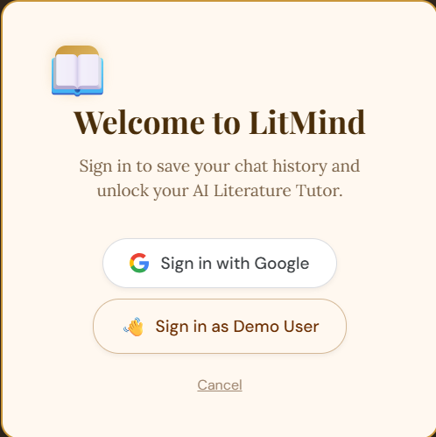

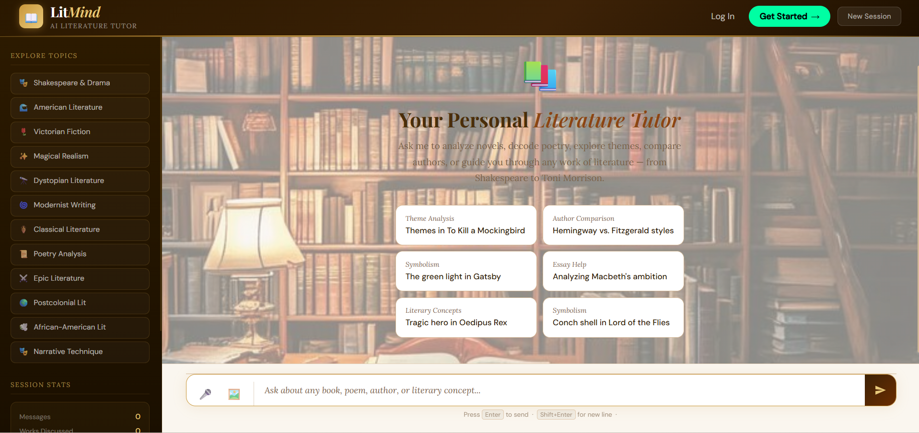



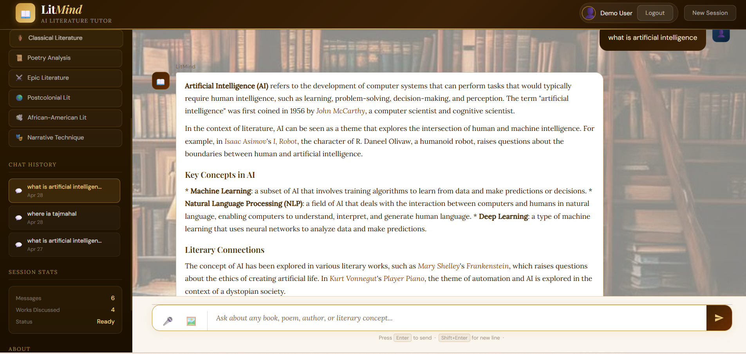

9)Conclusion:
LitMind successfully bridges the gap between advanced artificial intelligence and literary education by providing a sophisticated, user-centric tutoring platform. By integrating the Groq API and Llama 3.3 models, the application delivers near-instantaneous, scholarly insights into complex texts, themes, and narrative techniques. The implementation of a robust backend using Node.js and SQLite ensures that users can maintain persistent learning sessions, while Google OAuth provides a secure and seamless authentication experience. The project’s aesthetic design and responsive interface create an immersive environment that encourages deep literary exploration and critical thinking. Ultimately, LitMind stands as a powerful demonstration of how specialized AI tools can enhance the humanities, offering a personalized and accessible resource for students and scholars alike.
10)Future Scope:-
The future scope of LitMind involves expanding into multi-language support to enable the analysis of global literature in various native tongues. The project aims to integrate an interactive e-reader interface that provides real-time AI annotations and context-aware vocabulary assistance as the user reads. Collaborative features will be developed to allow students and educators to host group study sessions with a shared AI tutor for classroom environments. An automated essay evaluation system is planned to offer students immediate, detailed feedback on their literary arguments and structural writing quality. The platform will implement personalized learning dashboards that track user progress across different genres and recommend curated reading lists based on individual interests. Multi-modal capabilities, such as voice-activated tutoring and AI-generated visualizations of complex literary scenes, will be introduced to enhance user engagement.

11)Chatbot-Based Project Evaluation Questionnaire (INT428) :-
Student Name:
1)Donthireddy Harini,
2)Vamsi krishna,
3)Dharma Ayila
Roll Number: 71, 64, 18
Branch & Semester: Computer Science and Engineering (CSE) & 4th Semester
Project Title: AI Literature Tutor (Litmind).
Guide/Faculty Name: Mr. Anuj Attri.

12)Implementation Evidence and Screenshots:-
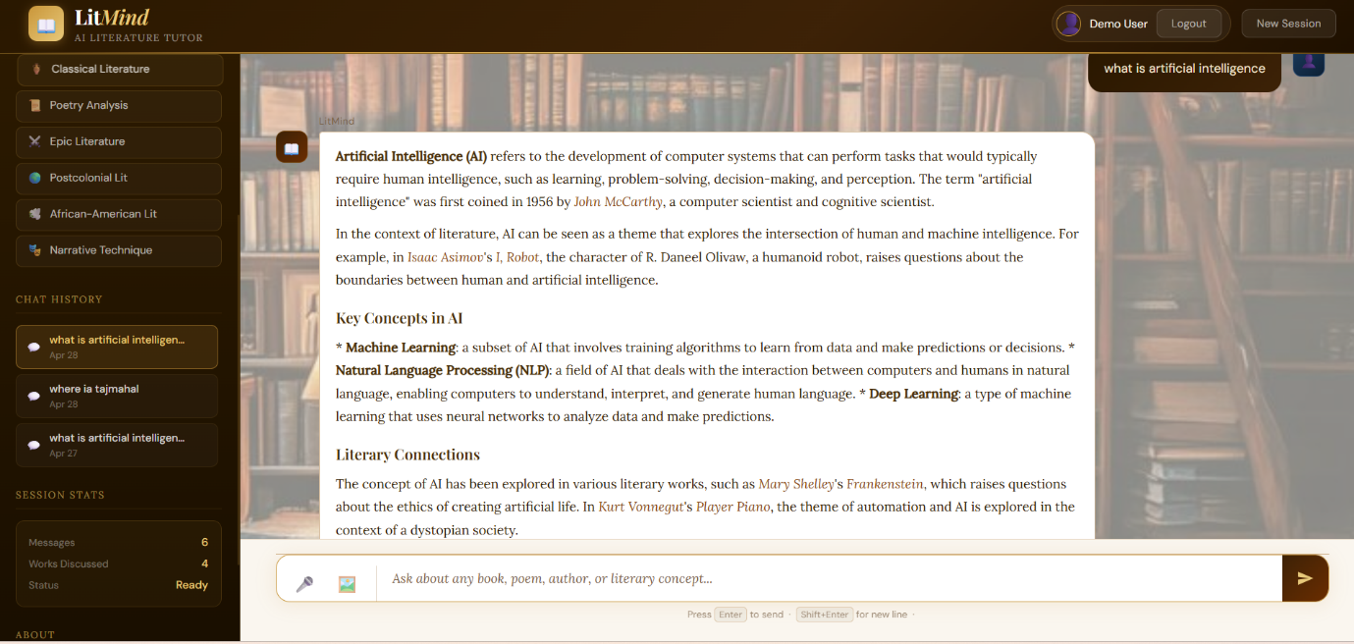

13)GitHubRepositoryLink: https://github.com/donthireddyharini/AI-Literature-Tutor.git
LocalHost Link:--
http://localhost:3000
RepositoryURL: https://github.com/donthireddyharini/AI-Literature-Tutor.git

Declaration I confirm that the information provided above is accurate to the best of my knowledge.
Student Signature: Donthireddy Harini,
Vamsi krishna,
Dharma Ayila.
Date: May 2, 2026.

